Name(s)_______________________________________________ Period ______ Date ___________________

|  |  |  |
| --- | --- | --- |
|  | **Activity Guide - Unreasonable Time** |  |

## Pair Raffle

**Problem:** For the pair raffle every participant gets a random ticket. A winning number is chosen, also at random. The problem is to determine if any pair of tickets add up to the winning number.

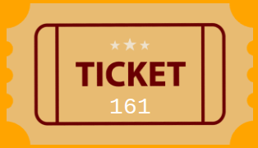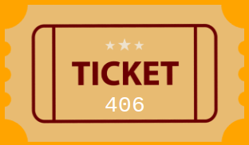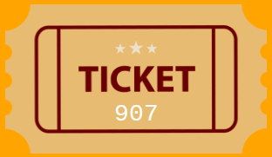

**Example Instances:**

* The tickets [108, 442, 913, 5] and a target number of 500. This instance does not have a winning pair.
* The tickets [250, 20, 4] and the target number 254. This instance does have a winning pair, 250 and 4.

**How Many Checks:** Fill in the table below with how many checks are necessary with different numbers of tickets. It may help to draw pictures and see if you start noticing any patterns emerge.

|  |  |
| --- | --- |
| **Tickets** | **Total Checks**  How many possible pairs are there? |
| 2 | 1 |
| 3 |  |
| 4 |  |
| 5 |  |
| Challenge: 8 |  |

## 

## Group Raffle Checks

**Problem:** For the pair raffle every participant gets a random ticket. A winning number is chosen, also at random. The problem is to determine if any pair of tickets add up to the winning number.



**Example Instances:**

* The tickets [411, 220, 710, 41] and a winning number of 1000.   
  This instance does not have a winning group.
* The tickets [110, 923, 475, 301, 102] and the winning number 1500. This instance does have a winning group, 923, 475, and 101.

**How Many Checks:** Fill in the table below with how many checks are necessary with different numbers of tickets. It may help to draw pictures and see if you start noticing any patterns emerge.

|  |  |
| --- | --- |
| **Tickets** | **Total Checks**  How many possible groups are there? |
| 2 | 3 |
| 3 |  |
| 4 |  |
| 5 |  |
| Challenge: 8 |  |

## 